Fair Compensation for Florida Exonerees
- Wrongfully convicted Floridians often spend decades behind bars for crimes they didn’t commit.

- Florida is one of 35 states with an exoneree compensation law that is supposed provide a direct, immediate way for the wrongfully convicted to access resources to rebuild their lives.

- However, only four exonerees have been compensated since the law passed in 2008, while more than 30 people were exonerated during that time.

- Most Florida exonerees don’t get a dime from the state and are forced to survive financially after being deprived of opportunities to build careers, establish savings and pay into retirement. The government that unjustly took their liberty doesn’t even cover bare necessities like food, housing and transportation.

- Taxpayers are harmed by the broken law because the alternative is for exonerees to file federal civil rights lawsuits. These cases cost taxpayers years of litigation expenses and there is no limit on the amount that can be award..

- Florida needs to fix the broken exoneree compensation law by:
- Removing the ‘clean hands’ ban
Orlando Boquete is barred from compensation for his 25 years of wrongful conviction because he committed another crime—escaping from the prison he never should have been in! Florida is the only state with a ‘clean hands’ bar on exonerees who were convicted of unrelated crimes—and it should be removed.

- Fixing the filing deadline.
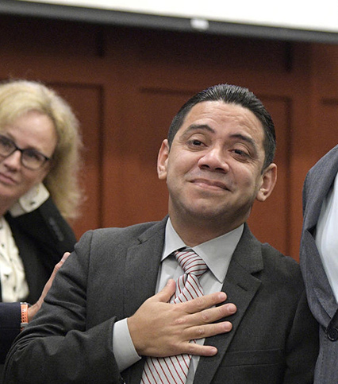
Clemente Aguirre-Jarquin was denied compensation after spending 14 years in prison--including a decade on death row—because he didn’t file within 90 days of his conviction being overturned, as required under the law. He couldn’t have filed at that point because the prosecutor decided to retry him and he was waiting in jail. Two years later the prosecution decided to drop the charges and he filed for compensation, but it was too late.

